Task 1: To Store Commands, Maintain History Buffer, Handle Capacity Limits, Retrieve Entries, Display History, Validate Consistency.
Code:
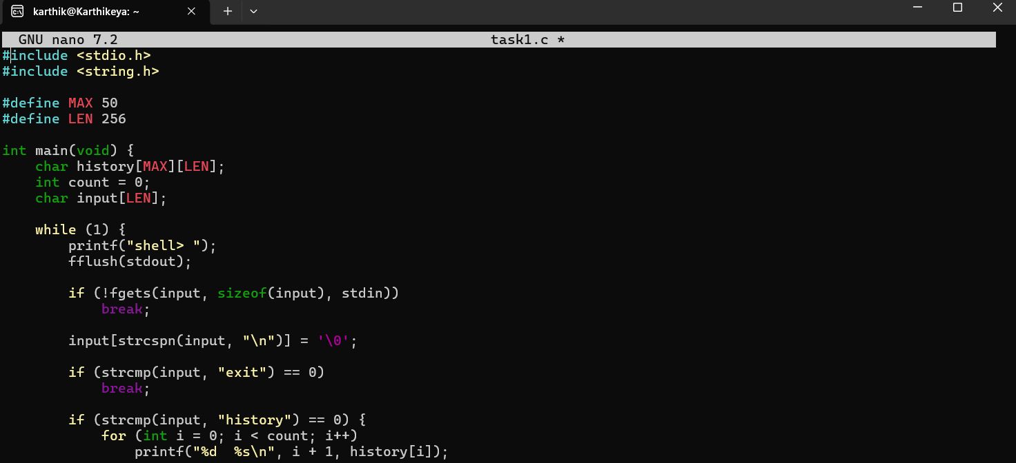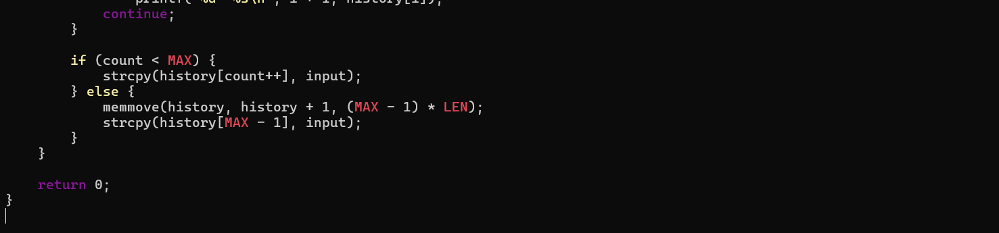

Output:
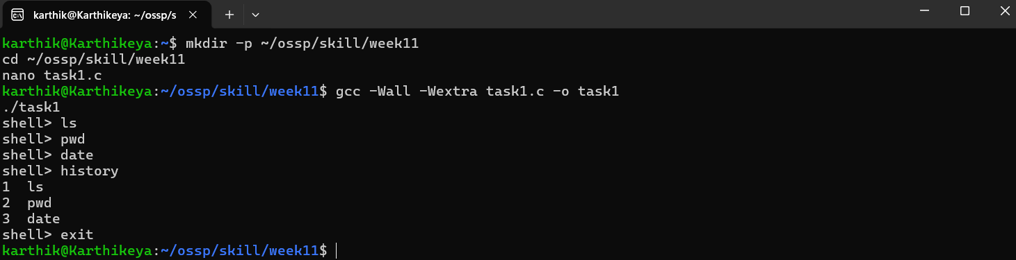

Task 2: To Create Pipeline Structures, Store Commands, Maintain Execution Order, Connect Processes, Validate Pipeline Layout, Test Configurations.
Code:
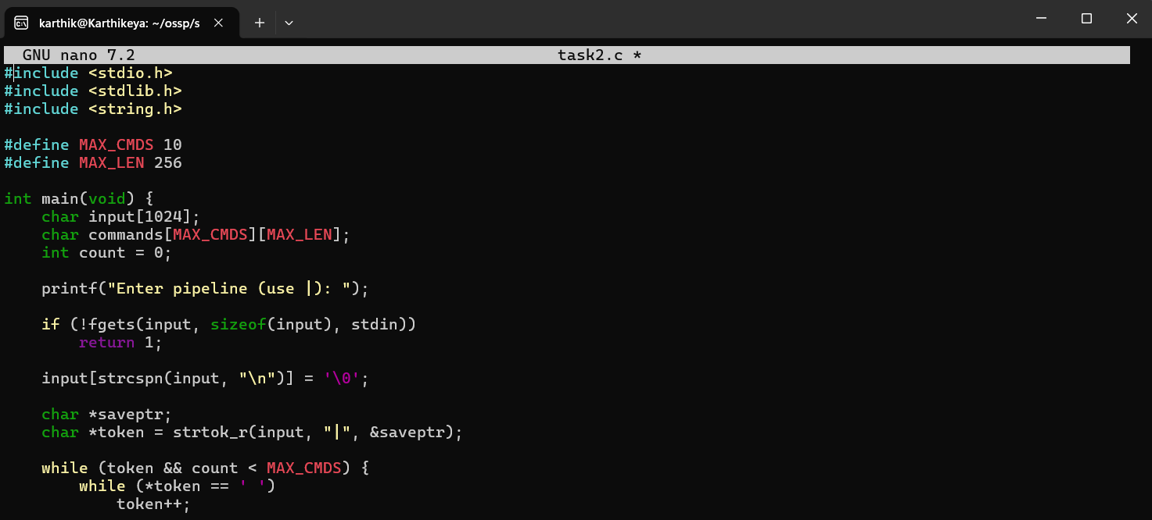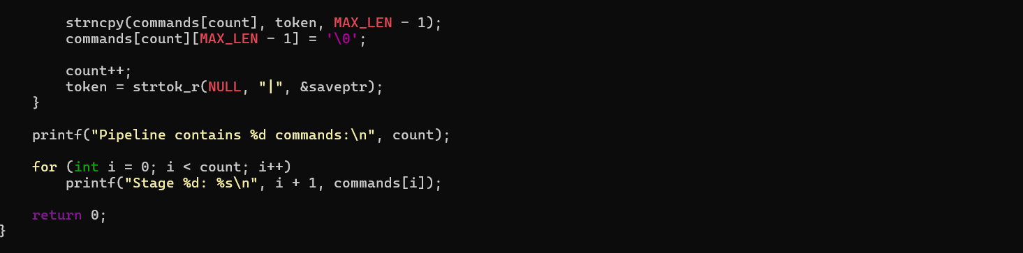

Output:
